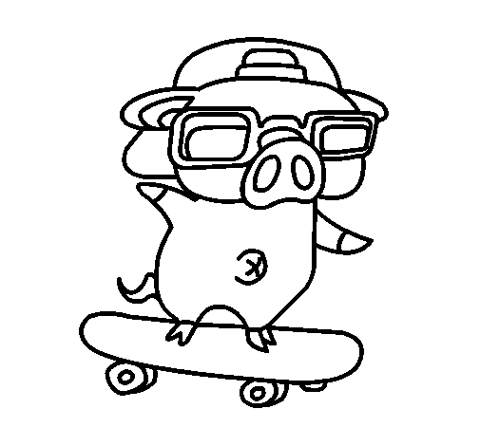
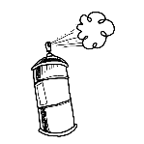
Vocabulary Choice Board
Graffiti Wall  Choose three vocabulary words. Write these words on a new sheet in graffiti-style. Add pictures and other words to show what the word means. The whole paper should be completely covered when you are done! | Real World Connection  Make a small poster using one of your words. This poster needs to include 3 connections.  -1 word to word  -1 word to world  -1 word to self | Song  Using a popular song or nursery rhyme, change the wording to include at least 5 of your vocabulary words. Make sure to change any other words around them to make them fit in and make sense.
Quiz  Create a 5 question quiz to give to a classmate, using 1 vocabulary word per question. Include an answer key for grading! | Sentences  For each of your words write a sentence that proves to me that you know what that word means. | 3 2 1  Choose 2 words. For each word write down 3 words to describe it, 2 sentences using it, and 1 question about it.
Crossword Puzzle  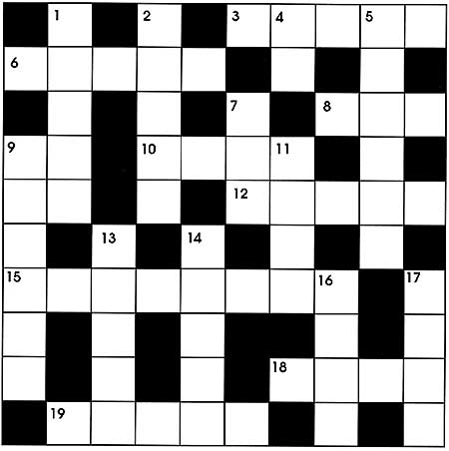  Choose 7 words and create a crossword puzzle. Include a list of clues to help us complete your crossword puzzle! | Same or Opposite?  For 3 of your words write a synonym to go with it. For a different 3 words, write an antonym to go with it. | Analogies  Choose 2 words. For each word you need to write a full analogy.  For example:  Dog is to Bark  As  Cat is to Meow
Name:____________Lesson:______

